San Bernardino’s Transit Network is the Region’s Best Kept Secret
San Bernardino County has a vast network of connecting public transit systems. The San Bernardino Transit Center serves as a connecting point for nine bus and train systems. Riders can take their local system to the Transit Center and transfer safely and quickly to get where they need to go, from Barstow to as far as Oceanside, or from Los Angeles all the way to Indio. However, most people may not be aware that this transit network is available.
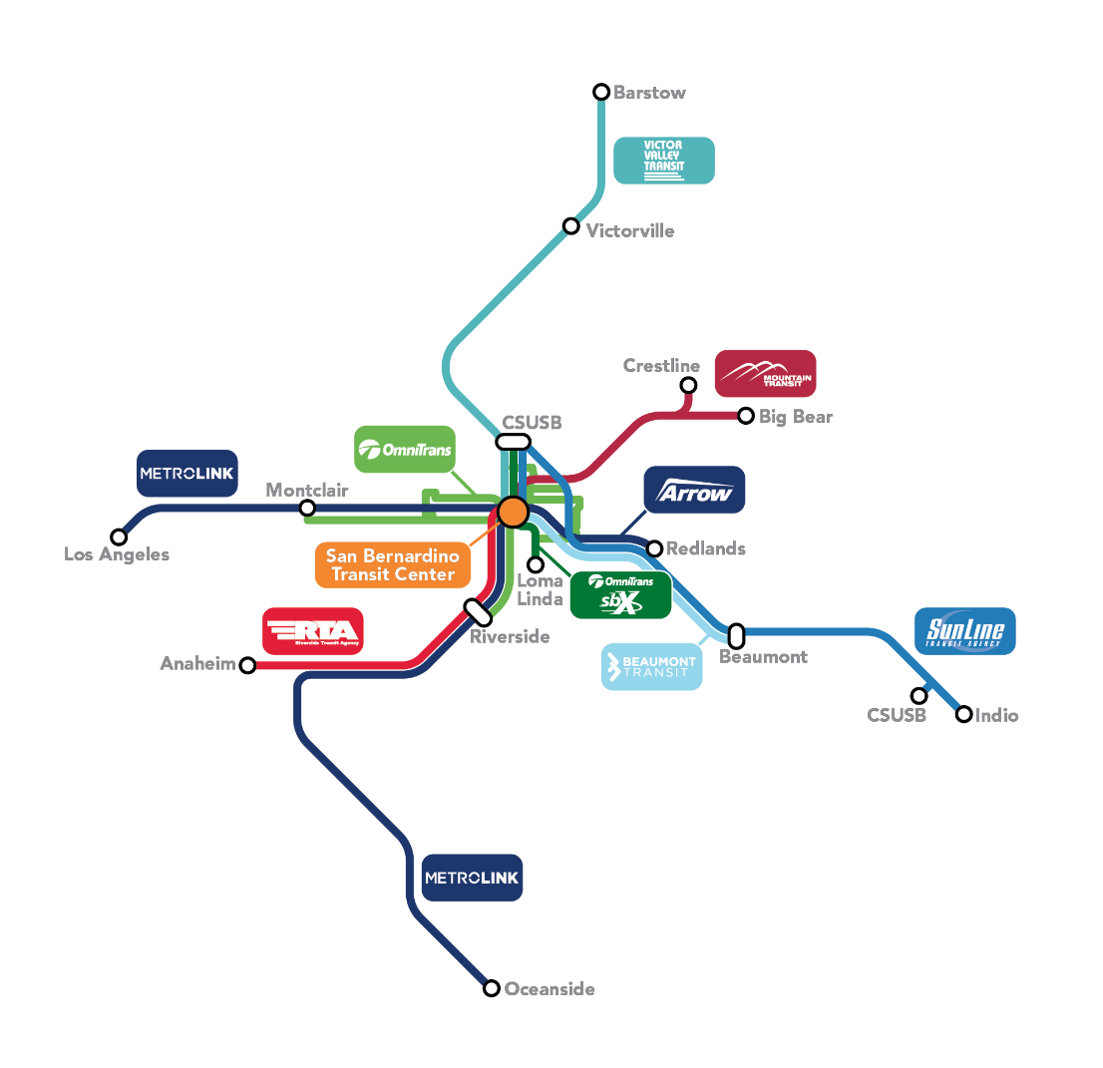
According to San Bernardino County Transportation Authority Board President, Dawn Rowe, “Only a handful of people—mostly transit professionals—are aware of the extent of the downtown San Bernardino transit network and the number of places you can go from the transit center. We want to rectify the situation and reveal the region’s best kept secret.”
To accomplish that, SBCTA is launching a promotional campaign to build awareness of the multi-modal transit network. Three rail lines and six bus systems are being featured in the campaign to educate residents that using transit in the San Bernardino region is easier than you think.
The campaign features a regional map that shows all the direct transit routes from the San Bernardino Transit Center. The systems are:
- Metrolink – Rail service to Los Angeles and Oceanside
- Arrow – Rail service to Redlands and San Bernardino
- Omnitrans – 12 bus routes to destinations throughout San Bernardino County and to Riverside County
- sbX – Omnitrans’ high frequency express service to California State University San Bernardino and Loma Linda Medical Center
- Victor Valley Transit Authority (VVTA) – Bus service to Victorville and Barstow
- Mountain Transit – Bus service to Crestline and Big Bear
- Sunline Transit – 10 Commuter Link Service to Indio
- Riverside Transit Agency (RTA) – Route 200 to Riverside and Disneyland
- Beaumont Transit – Route 120 to Beaumont and Cabazon
In addition to the regional map, the campaign uses various trip scenarios to illustrate the ease of taking transit throughout the region. In one scenario, two teens from Crestline who snowboard in the winter are looking for some summertime fun. They catch the early Mountain Transit Route 6 from Crestline to the San Bernardino Transit Center, then transfer to RTA route 200 which drops them off less than a five-minute walk to Disneyland.
Board President Rowe notes, “Most teens in the region have no idea that they could go to Disneyland for a day without driving. There are so many opportunities like this that people simply aren’t aware of.”
Other scenarios include commuting from one city to another without the daily grind of driving, traveling from remote Barstow to the Loma Linda Medical Center, getting to the Ontario Airport, and connecting to fun activities in Downtown Los Angeles, Riverside and Indio.
Where Did You Go?
SBCTA will be holding a “Where Did You Go?” quarterly prize drawing to learn how you used San Bernardino County’s Transit Network for your day-to-day or adventure travels.
To learn more about the San Bernardino Transit Network, planning your own trip or to tell us about your experience using our regional network, visit goSBCTA.com/transit.

